3KE5 -

Functionality
Assessment of relevant overhead costs is performed at period closing (actual data) or plan closing (plan data). The values of head office/admin profit center that are not related to a product group will be allocated to the product group profit centers in order to have a complete income statement by product by company code.
Allocations of cost and revenues (Assessments) will only take place in Profit Center Accounting where they cannot be carried out in Controlling.

Scenario
We perform assessment for profit center 7000 in period 7 and year 2002.

Requirements
Relevant costs and revenues for assessment sender rule must be posted to sender profit center ‘7000’ in this period.

Menu Path | SAP menu → Accounting → Controlling → Profit Center Accounting → Actual Postings → Period-End Closing → 3KE5 - Assessment
Transaction Code | 3KE5

1. Double Click on 3KE5 - Assessment

Execute Actual Assessment: Initial Screen

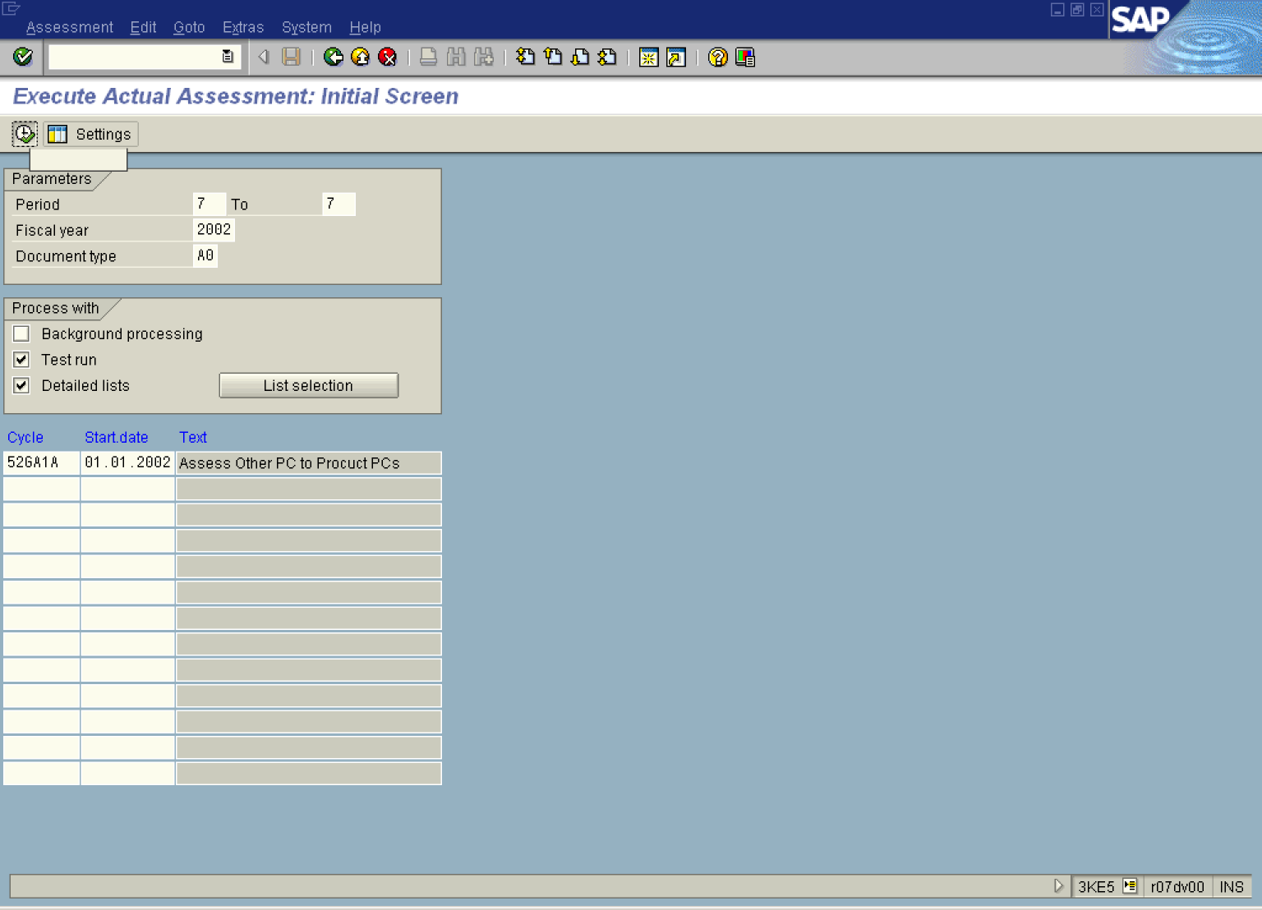

2. Update the following fields:
Field Name | Field Description | Values
Period | From period | Example: 7
To | To Period | Example: 7
Fiscal year | Description of the relevant Fiscal year. | Example: 2002
Document type | Relevant document type for actual postings in PCA | Example: A0
Cycle | Relevant name of a cycle | Example: 52GA1A

3. Click Test run .

4. Click Detailed lists .

5. Click Enter .

6. Click Button .

Display EC-PCA: Actual Assessment Basic list

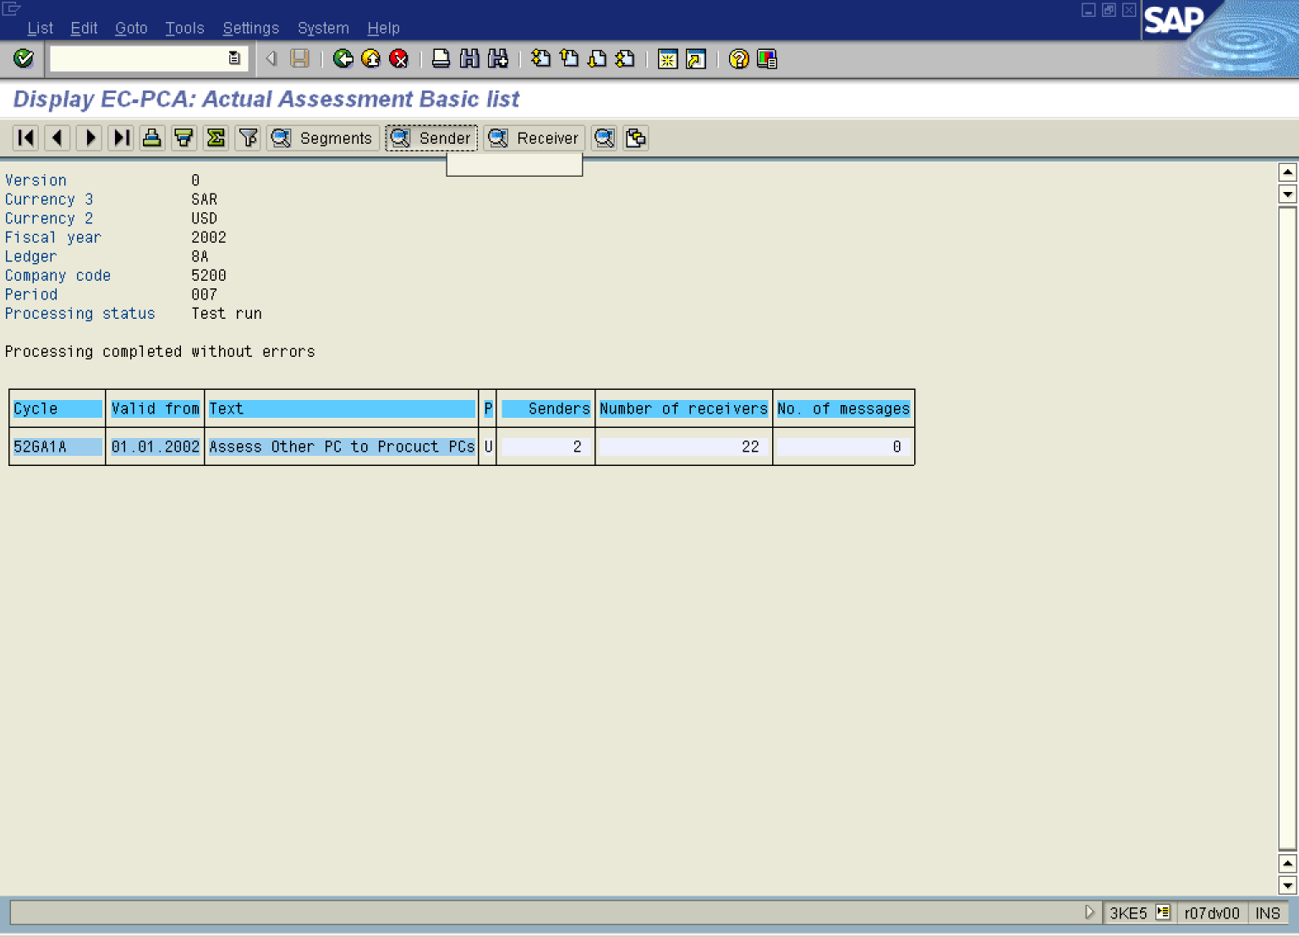

7. Click Sender Button .

Display EC-PCA: Actual Assessment Sender list

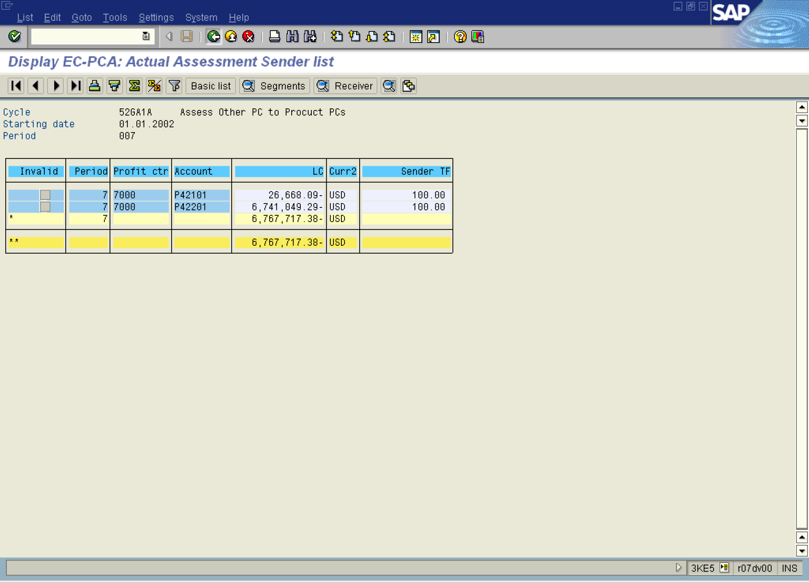

8. Click Back .

Display EC-PCA: Actual Assessment Basic list

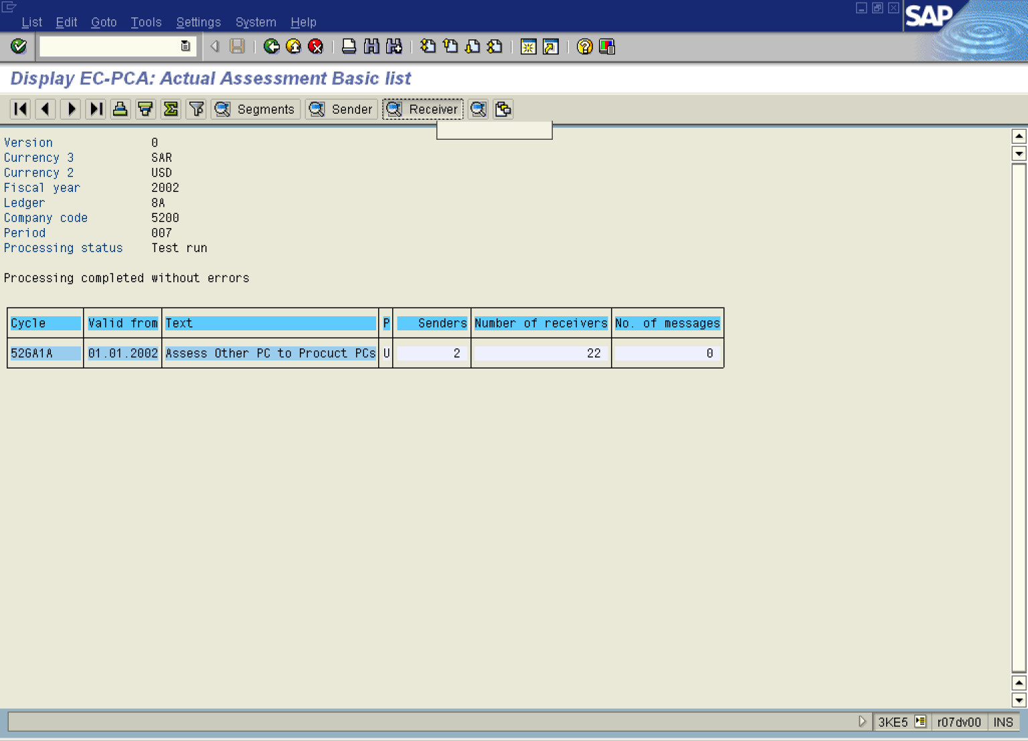

9. Click Receiver Button .

Display EC-PCA: Actual Assessment Receiver list

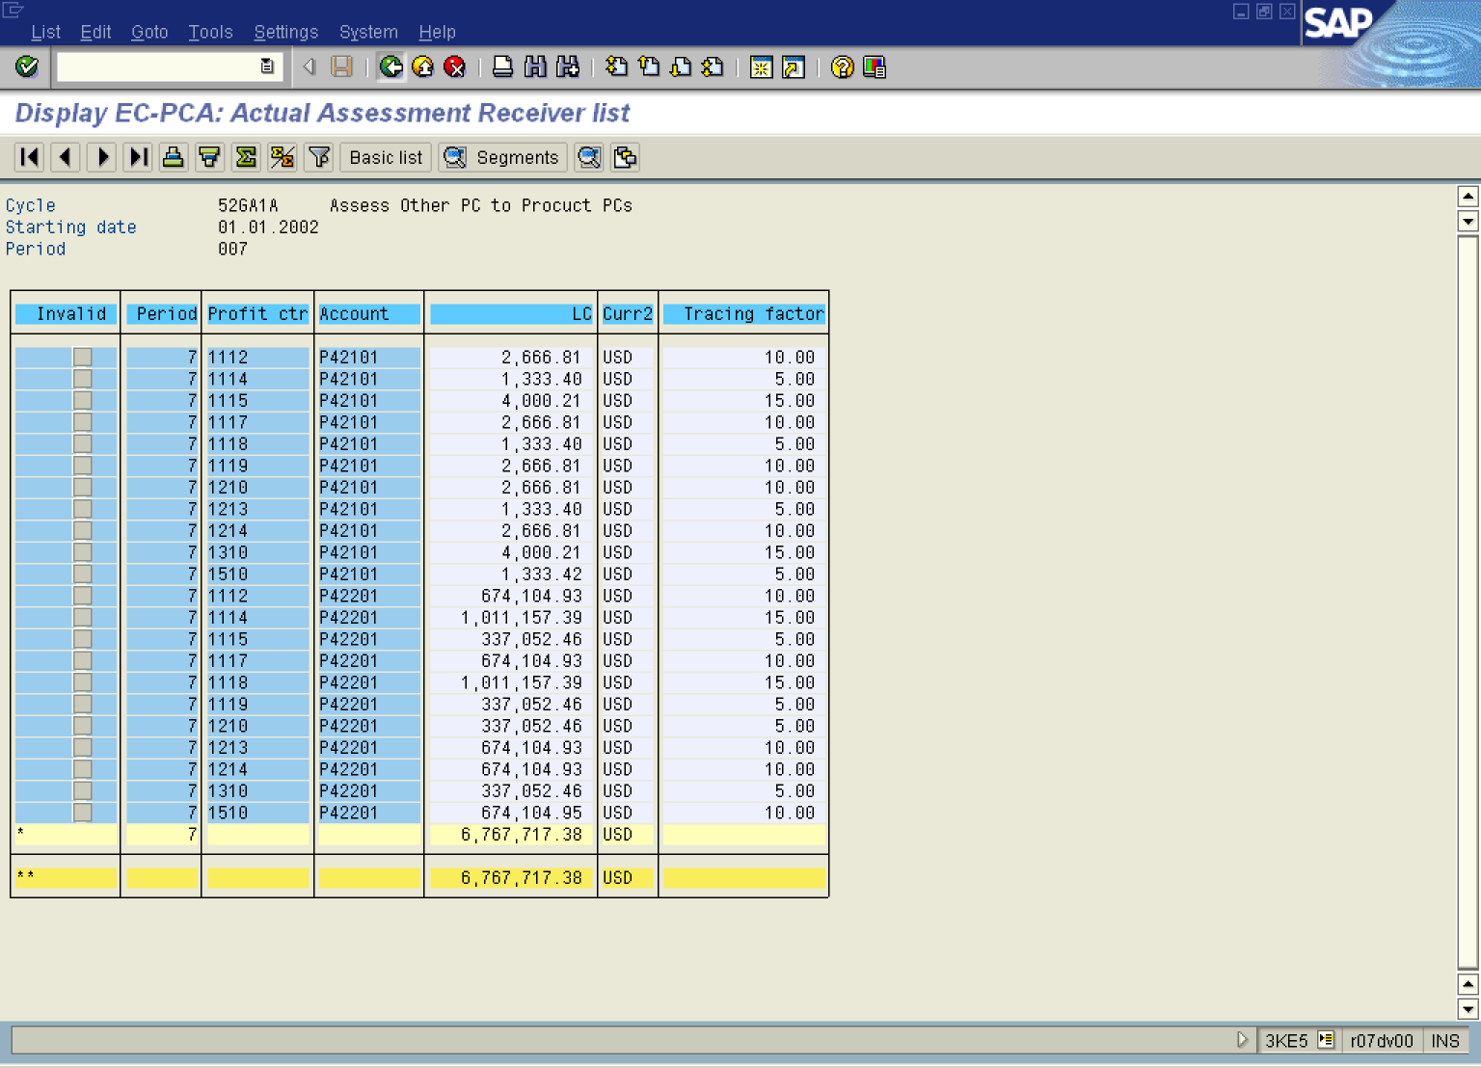

10. Click Back .

Display EC-PCA: Actual Assessment Basic list

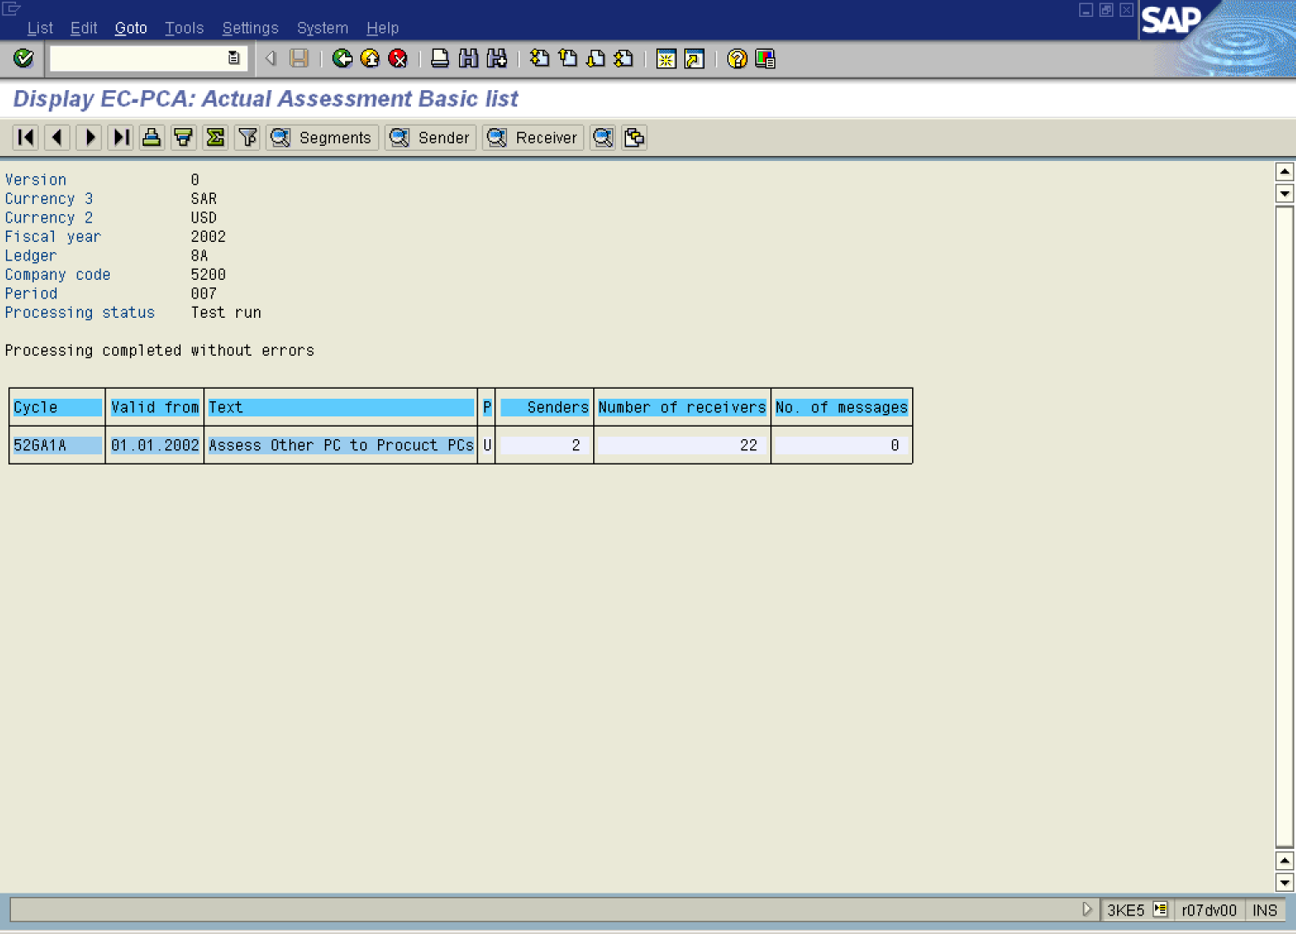

11. Select GotoMessa gesChoose.

Display EC-PCA: Actual Assessment Basic list

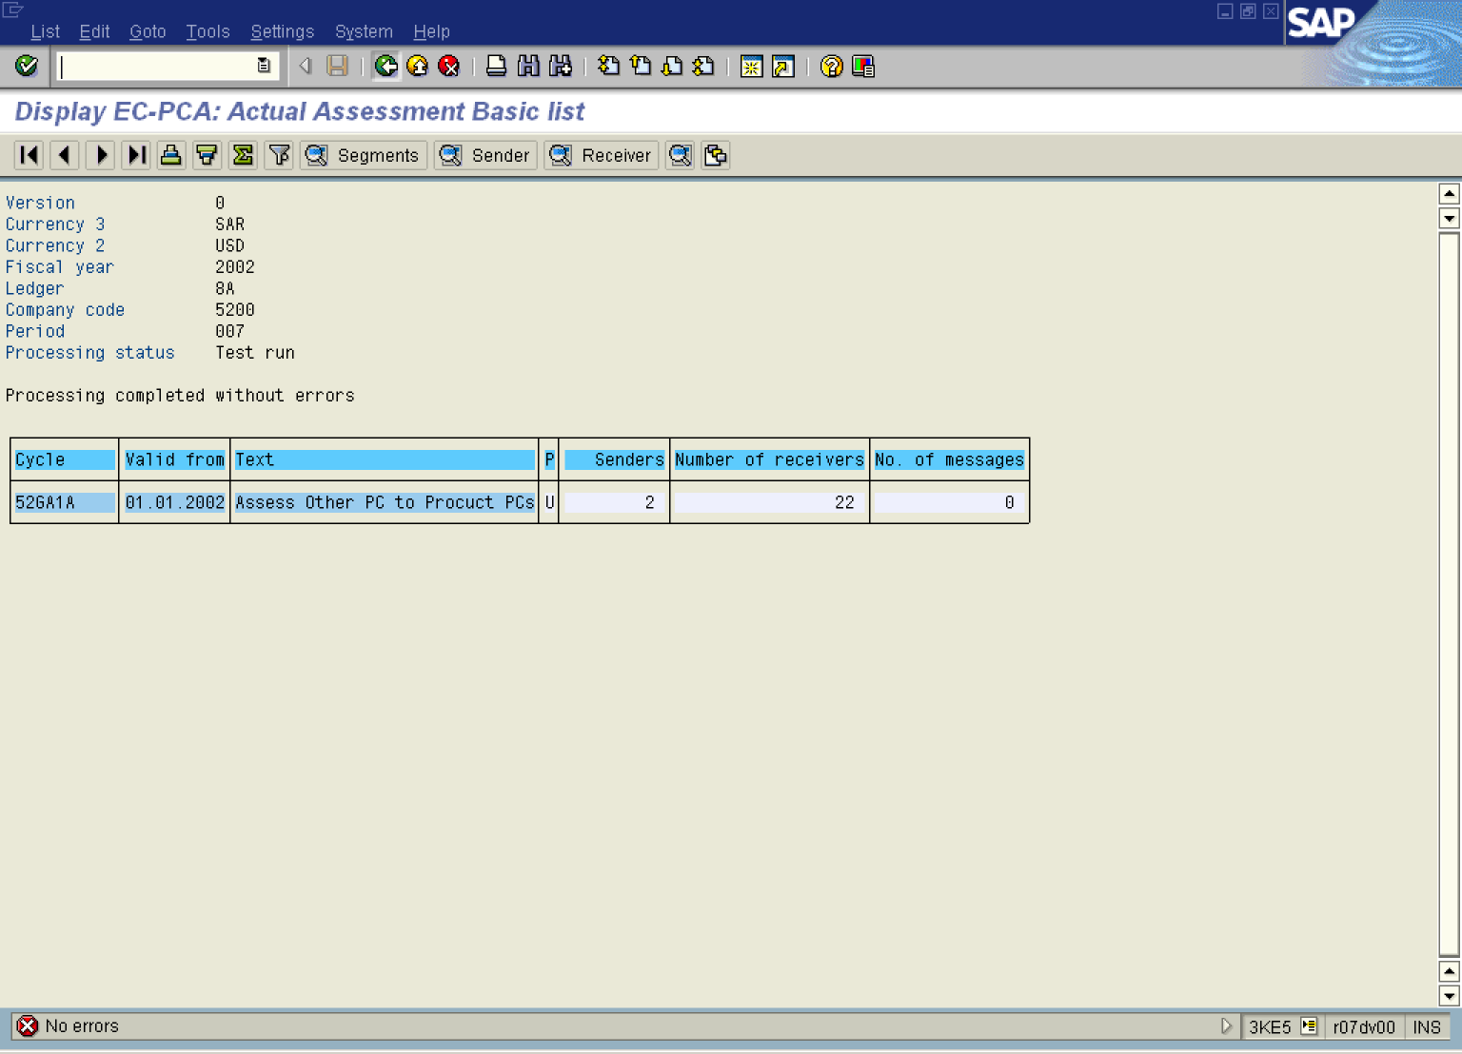

12. Click Back .

Exit list

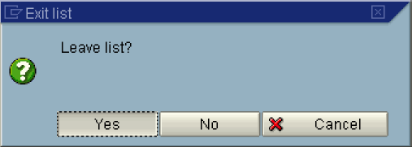

13. Click Yes Button .

Execute Actual Assessment: Initial Screen

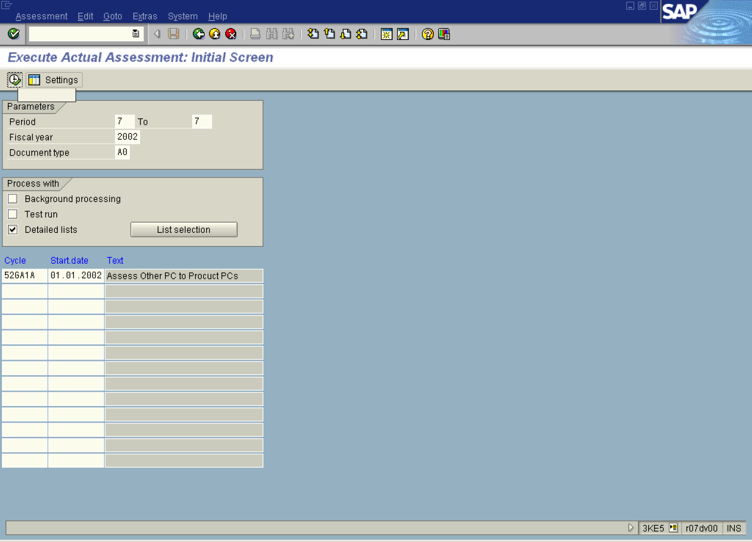

14. Click Test run .

15. Click Button .

Display EC-PCA: Actual Assessment Basic list

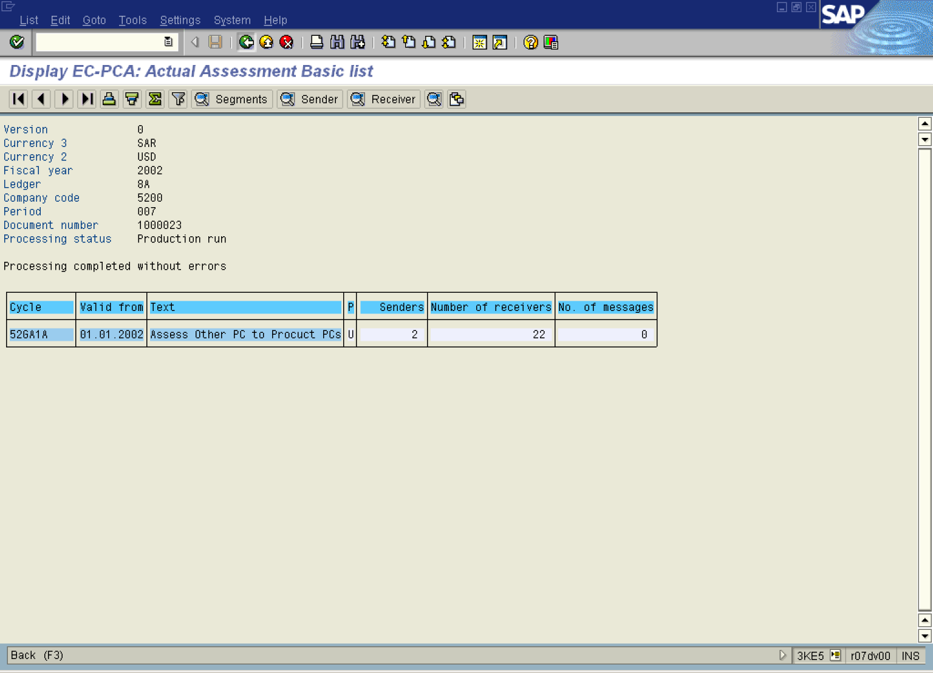

16. Click Back F3 .

Exit list

17. Click Yes Button .

Reverse Actual Assessment: Initial Screen

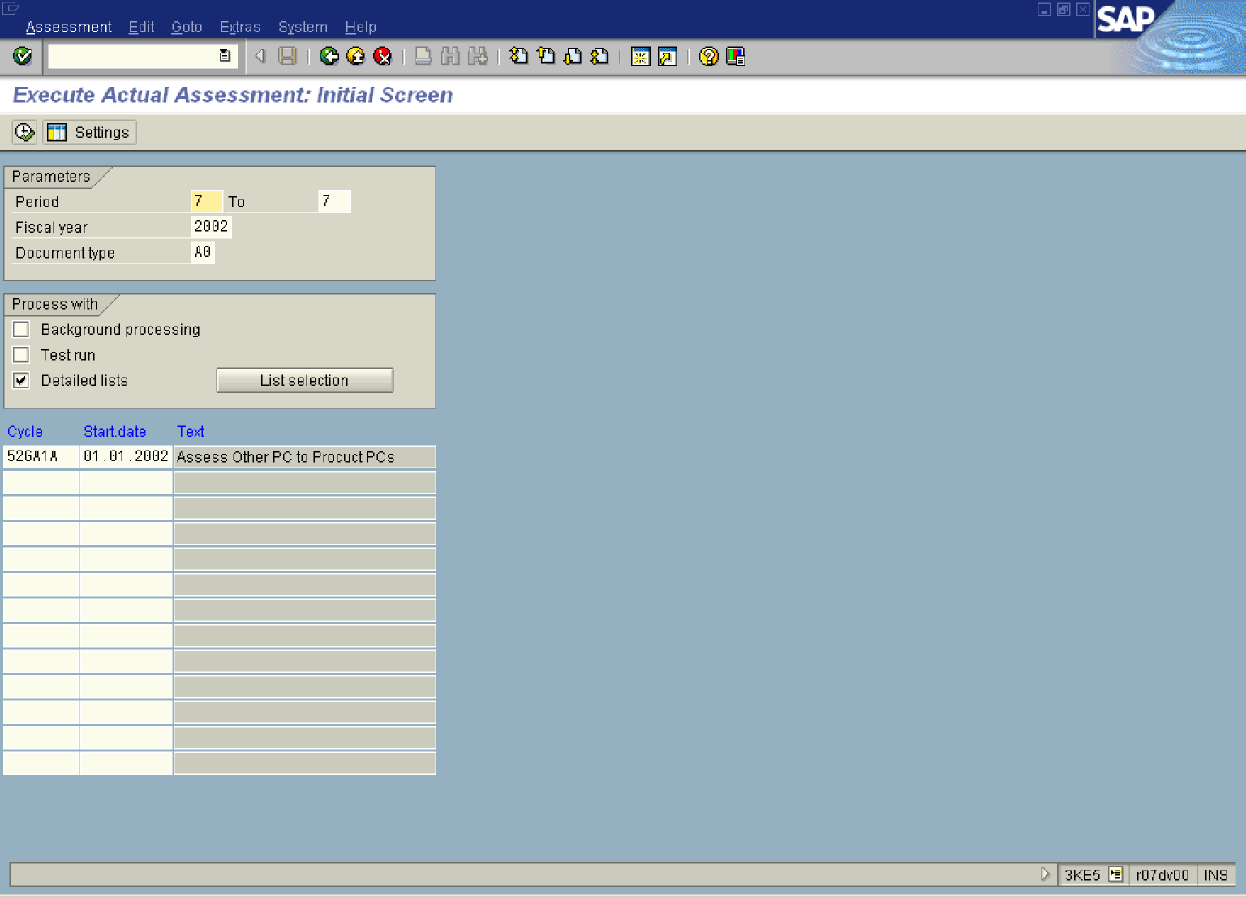

18. Select AssessmentReverse.

Information

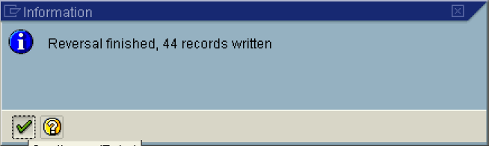

19. Click Button .

Execute Actual Assessment: Initial Screen

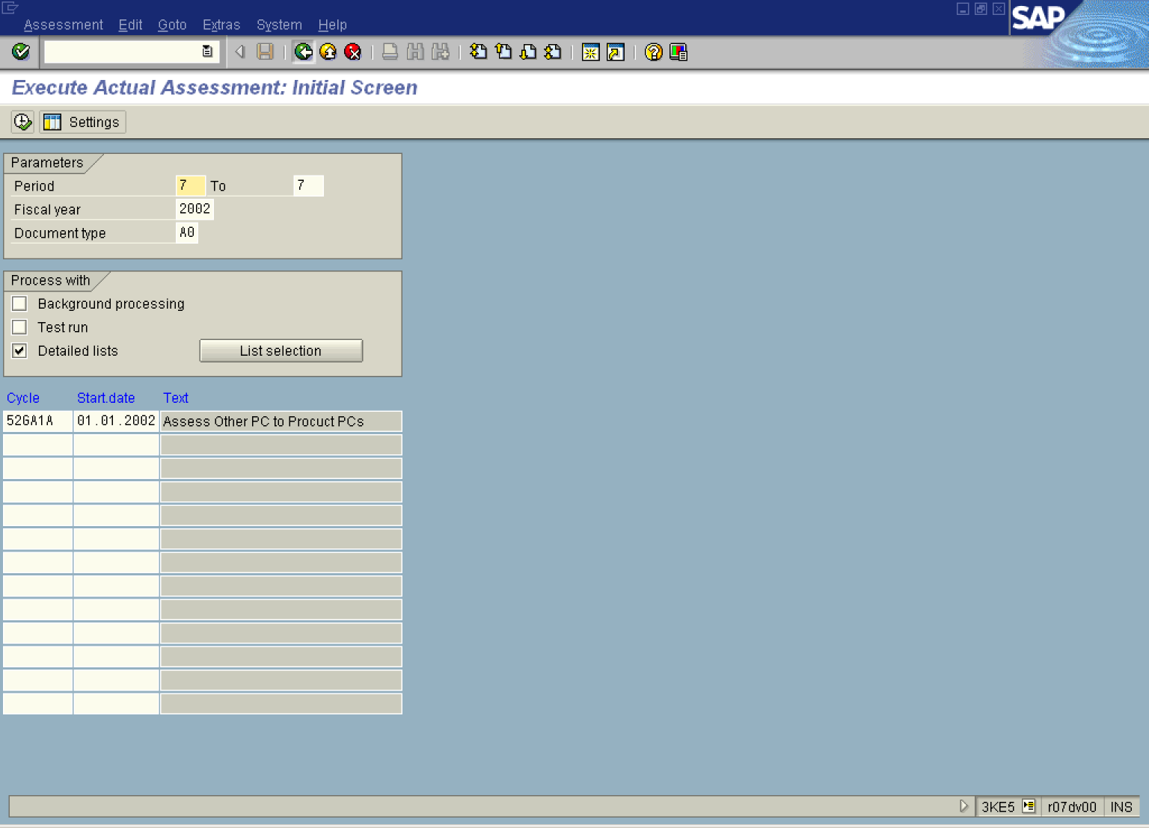

20. Click Back .

